Onward! |  |  |  | Spring 2014  Edition
A Newsletter for the 4th Day of the Scranton, Pennsylvania, Cursillo Community
Divine Mercy Sunday

The world was in the midst of the Great Depression in 1931 and the memories of World War I were still very much alive in the minds of people when in Poland a sister of the Congregation of Sisters of Our Lady of Mercy, Faustina Kowalska (1905-1938), is said to have been personally visited by Jesus.

According to her diary, an image was revealed to her of the risen Lord, from whose heart shone two rays, one red (representing blood) and the other “pale” (symbolizing water), with the words “Jesus, I trust in you” at the bottom. Faustina wrote in her diary that Jesus told her, “I promise that the soul that will venerate this image will not perish.”

When she was canonized in
2000 under the direction of fellow countryman Pope John Paul II, he proclaimed that the Second Sunday
of Easter would from then on be known as Divine Mercy Sunday.

Give thanks to the Lord for he is good for his mercy endures forever.
Psalm 118


According to the revelations to St Faustina, participation in the Holy Mass, reception of the Sacraments of Reconciliation and Eucharist on Divine Mercy Sunday are means to obtain full remission of sins. Recitation of the Divine Mercy Chaplet and veneration of the image of Divine Mercy are parts of this devotion. We can also say the novena in preparation for the feast, starting on Good Friday.

The message of The Divine Mercy is simple. It is that God loves us — all of us. And, he wants us to recognize that His mercy is greater than our sins, so that we will call upon Him with trust, receive His mercy, and let it flow through us to others. Thus, all will come to share His joy.
Patricia O’Reilly
God Bless Father Ed

The only thing missing from Fr Ed’s celebration was oysters on the half- shell! What an evening was had by all who joined Fr Ed Buchheit in celebrating his Jubilee, the 50th anniversary of his ordination in 2013.

The evening began with a beautiful Mass at Queen of Apostles in Avoca. Fr Phil Sladicka graciously hosted the entire event and was concelebrant for Mass. Our “Cursillo Choir” had lovingly prepared the music for the liturgy and it was very moving. Cursillistas offered their service in the various roles for the laity in Mass. After painstaking practice at the Teams’ sleep-over and School of Leaders, the Cursillo community sang Salve Regina in honor of Mary, Our Queen and to mark the significance of the event…beautiful!

After Mass, Fr Phil delivered the closing remarks, honoring Fr Ed’s priesthood and contribution to Cursillo. Then the gift was presented, which included a Cursillo themed stole (pictured below), complete with a rooster on one side and DECOLORES stitched on the other in a rainbow of colors. Embroidered on the inside of the stole were the words, ‘With love from your Cursillo Family, 2/22/2013’, the date marking Fr Ed’s 50th anniversary.

Then it was off to dinner and dancing! A warm welcome to all was given by our Lay Directors, Joe and Margie Adcroft. The food was wonderful, the company great, and the conversation joyful. Our own Geri Featherby and John Olcese with E-City Sound (ecitysound.com) gifted us all with their incredible talents. Geri requested contributions from whoever wanted to add to the creation of a parody about Fr Ed prior to the event. Gary Cangemi, creator of Umbert the Unborn, cleverly composed the parody and Geri sang it to the tune of My Favorite Things. What fun! Gary also joined us for the festivities. Here are a few lines:
Pro-life themed tee-shirts and car bumper slogans
Big birthday bashes up at Doc Magrogan’s
Oysters and crab legs and calamari rings
These are a few of my favorite things.

Lastly, Fr Ed gave his all with a Polka lesson that would put Dancing with the Stars to shame. Love, laughter and joy filled the room. How blessed we are to have Fr Ed, Fr Phil, all our priests, deacons, religious sisters and each other! Our Heavenly Father must have been looking down on us with a great big smile. DeColores! Your sister in Christ,
Donna Valenti
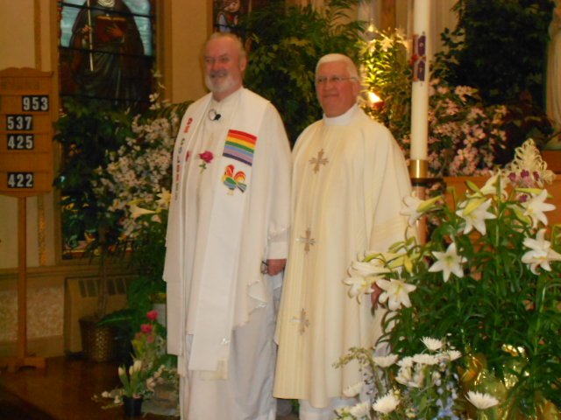
Fr Ed Buchheit and Fr Phil Sladika

We must keep spreading the good news –  Make a Friend,  Be a Friend and  Take that friend to Christ. | National Cursillo $3.00 Campaign  $3/YR Campaign Update FROM April 2014 National Newsletter –  As of March 14, 2014, the National Cursillo Center has received a total donation amount of $33,031. This amount is up 10% from January 2014. They have reached 11% of their $300,000 goal for this fiscal year.  Please continue donating to the Campaign. For more information about the $3 a Year Campaign, visit their website at HTTPS://WWW.Natl-Cursillo.org/donate/ or see our Treasurer, Cindy Hogan, with your donation. She will have all donations forwarded to the National Center.
The More We Get Together...

We meet in the rectory basement every week, the four of us. The conversation sometimes strays to the Polish National Church or the Valley View girl’s softball team but we always go back to our purpose--planning the next evangelization project for our parish. We are rather small but there is unbelievable fire in a common mission. We are the Cursillistas of St. Mary's in Dickson City. We've worked on organizing retreats in our parish, book studies, book distribution, and other liturgical events that we think will bring more people to Christ. We are not unique--there are lots of groups like us--and I'm sure they'd all agree that there is nothing like working with a likeminded brother or sister in Christ.
All around the Diocese, groups of Cursillistas are transforming their parishes together. I've seen it at Our Lady of the Snows--a dedicated group of a dozen Cursillistas work together to put on a Living Christ Retreat that is ALIVE in the Spirit. From the people who give the talks on their retreat to the people in the kitchen, you recognize Cursillistas' beaming faces. At St. Eulalia's, the choir is full of Cursillistas lifting their voices to the heavens, transforming their parish through music. At Nativity of the BVM in Tunkhannock, their Women's Group organized an initiative to get good Catholic books for teens and adults to distribute. I know of various Groups that have raised funds to provide meals for the hungry, organized special services or Masses at their parish, or participated in a Holy Hour together for a special intention. I believe these groups are so successful because they are in the same place; people sense their authenticity. We are so powerful when we work together.
Working on projects with fellow Cursillistas in the parish is a great blessing. We are not afraid to do the grunt work. We're not there to be thanked. We're not there to increase in stature or rank. We just want to see Christ more alive in our parish. Best of all, people usually say, "How did you get this way?" and we have the opportunity to share our love for the Father. If you have fellow Cursillistas in your parish, consider bringing them in and working on a project together. Even look toward your own Group and plan something from there. You will be amazed and enlivened by the impact just a few can make. Christ is counting on us!
Amanda Schwenk
The Journey of Two Popes

Another important event happening on April 27, 2014 besides Divine Mercy Sunday is the canonizations of Pope John XXIII and Pope John Paul II. This will be a most joyous occasion in the recognizing of these two great men.

This will be the first time that two popes will be canonized at the same time. They are two men whose lives were completely dedicated to the spreading of the Holy Gospel. All through their reigns as Pope, they always reached out to the poor and helpless and they provided strong leadership needed to keep the Church on course through some difficult times.

Pope John XXIII is known as the Pope of the People and Pope John Paul II is known as the Pope of the World. Blessed John XXIII, known particularly for convening the Second Vatican Council, was pope from 1958 to 1963; Blessed John Paul II beatified him in 2000. Blessed John Paul II served as pope from 1978 to 2005 and was beatified by Pope Benedict XVI on Divine Mercy Sunday, May 1, 2011.

I don’t think it’s a coincidence that John Paul II and John XXIII will be canonized on Divine Mercy Sunday because both men brought such mercy into our world. They were wonderful examples of God’s endless love for us all and showed humble leadership that transformed the world. Let us pray that through their intercession as saints, the heavens will open wide and even the most toughened hearts will accept God’s gift of Divine Mercy.
Patricia O’Reilly

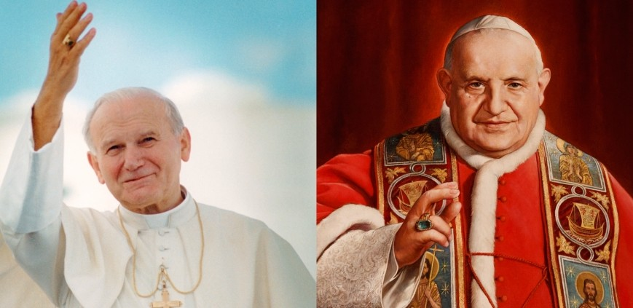

LOUGH DERG

Over the black waves
Of the lake trip the
Lost echoes
Of the bell that has
Shooed through the
Chapel door
The last pilgrims like
Hens to roost Patrick Kavanagh, Irish Poet

Last October, while in Ireland, I had the amazing privilege of touring Lough Derg , known as St. Patrick’s Purgatory. It was extra special, as it was a private experience involving Pat and Tony O’Reilly, Cindy and Jim Hogan, and me. Tony, our “tour guide”, had lived the Three- Day Pilgrimage, while preparing for his service as Rector.
Many special graces flowed that day, as we accompanied Tony’s reliving, to a small degree, this special and powerful pilgrimage. From a barefoot decade of the rosary prayed together as we processed around St Mary’s Church (as the entire pilgrimage is lived barefooted), to kneeling at the water’s edge in prayer and meditation…the experience, like Cursillo, is one that has to be lived for the deepest meaning. Before praying our decade, Tony showed us how the pilgrims, at St Bridget’s Cross, would say goodbye to the world, the flesh, and the devil. I remember that as I knelt by the water, listening to the sound of waves gently rushing against the shoreline, I prayed to God to remove any thorns that were suffocating His seed within me…to wash those thorns from my heart with the waters of Lough Derg, were so many pilgrims had sacrificed and prayed.
In the Adoration Chapel, we took a moment to individually offer prayers of thanksgiving …the Blessed Sacrament was not there at the time, but Christ certainly was. I noticed an unusually pleasant aroma, not exactly like flowers or incense, but lovely and pleasing…something I took as yet another gift from God.
The Penitential Beds, remnants of ancient monastic bee-hive cells, served as a kind of prayer garden, difficult and beautiful at the same time…like the Crucifix that was the central hallmark of each station. Leaning on Christ, both spiritually and physically, the pilgrims often need to hold onto the Cross to rise from kneeling due to their exhaustion from fasting and little sleep.
On the top of the peaks of the various buildings on the island, there were different symbols, one of which happens to be a rooster! But, my favorite was a small rowing boat carrying four pilgrims…depicting the notion of journey. We are all on a journey, with each other, as our loving Father has willed.
These are only some of the wonderful experiences that our visit to Lough Derg provided. Cindy pulled out her Pilgrims Guide and together we prayed the Thanksgiving Prayer After A Deeply Religious Experience which includes these words: This time has inflamed my heart, renewed my dreams, and enabled me to see with divine eyes. How grateful I am for such a special time in my journey!
They that hope in the Lord will renew their strength, they will soar as with eagles’ wings; they will run and not grow weary, walk and not grow faint. Isaiah 40:31
JOURNEY ON! DeColores! Donna Valenti
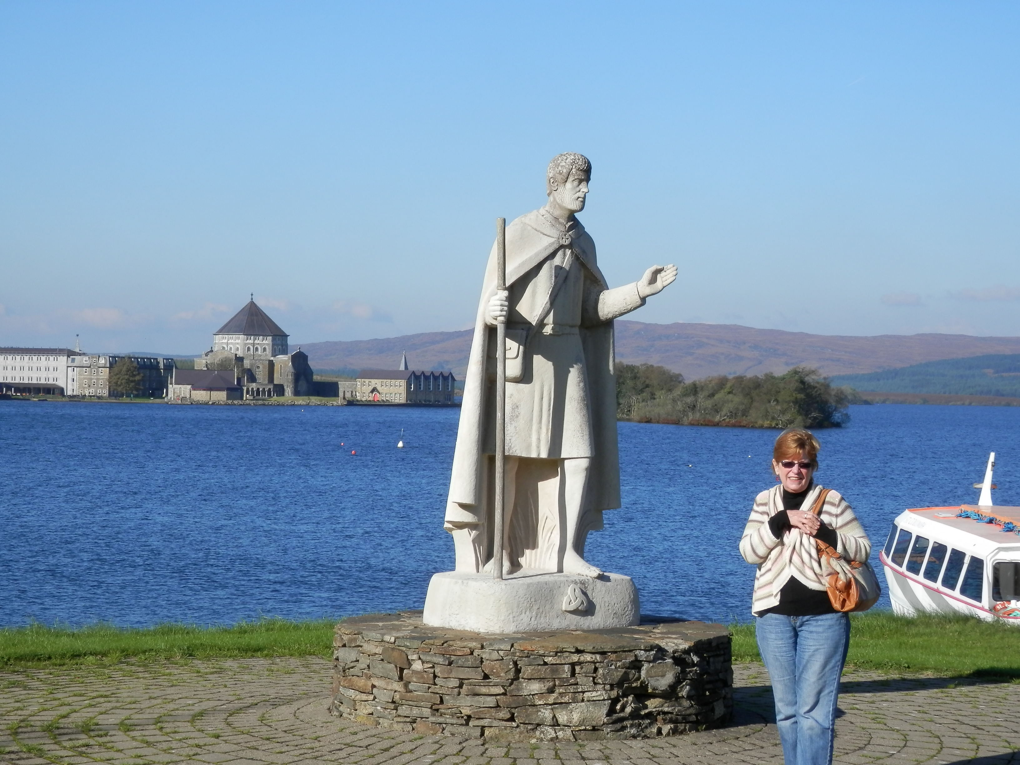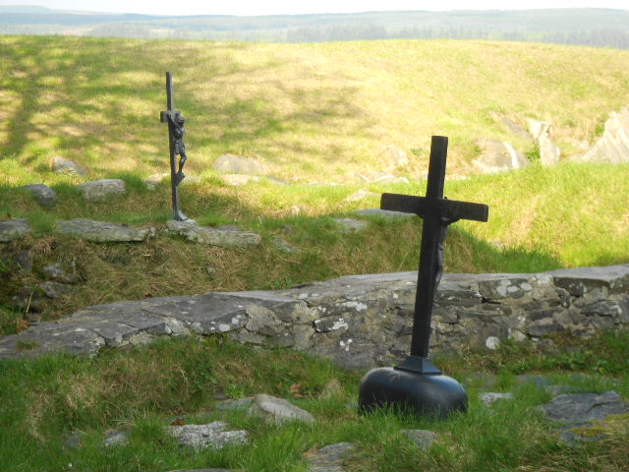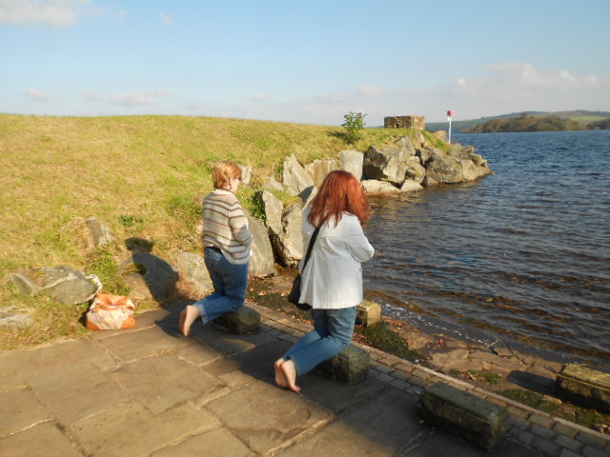
Cindy at the dock to Lough Derg Penitential Beds Donna & Cindy Praying at Waters Edge

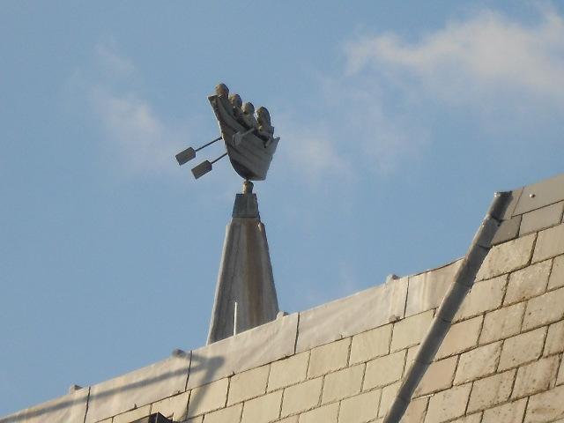Boat Carrying Pilgrims

Scranton Cursillo Newsletter  ATTN: Patricia O’Reilly  Phone  (570) 422-1322  E-mail  Snuffpat@aol.com  Go therefore, and  Be Messengers  of JOY!  ~ Blessed Pope John Paul II | Upcoming Events !  65th Women’s Cursillo – Oct 2 – 5, 2014  - 57th Men’s Cursillo – Spring, 2015
 | SCHOOL OF LEADERS  Saturday, April 26, 2014 - Our Lady of Snows, Clarks Summit (9:30 -11:30) - School of Leaders  Saturday, May 24, 2014 –  St. Eulalia, Elmhurst (9:30 -11:30) - School of Leaders  Saturday, June 14, 2014 –  Our Lady of Snows, Clarks Summit (9:30 -11:30) - School of Leaders  Saturday, July 12, 2014 –  St. Vincent, Dingmans Ferry  (9:30 -11:30) - School of Leaders  Saturday, August 23, 2014 –  St. Vincent, Dingmans Ferry  (9:30 -11:30) - School of Leaders  Saturday, September 13, 2014 - Queen of Apostles, Avoca  (9:30 -11:30) - School of Leader | ULTREYAS  Sunday, May 4, 2014 - St. Vincent dePaul,  Dingmans, 2 - 4 pm, in the parish hall  Wednesday, June 11, 2014 - Queen of Apostles,  Avoca after the 7pm Mass – Ultreya  Sunday, June 22, 2014 - Our Lady of Snows.  Clarks Summit, 2 - 4 pm - Ultreya  Sunday, August 10, 2014 - Our Lady of Snows.  Clarks Summit, 2 - 4 pm - Ultreya

About Our Movement
Cursillo (pronounced cur-see-yo) is Spanish for little course, specifically in the teachings of Jesus. The goal of the Cursillo Movement is to make Christ the prime influence in society. Cursillo is often described as a retreat. While there is quiet time and reflection, there is more discussion among peers than in most retreats. Perhaps, it is best described as an experience of living in Christian community.

The Cursillo Movement is worldwide. It began in Spain in the mid-1940s and came to the United States in the 1960s. All local dioceses in the US are affiliated with the worldwide Cursillo through the National Cursillo Secretariat in Dallas, Texas.
The Cursillo weekend in the Diocese of Scranton begins Thursday evening and ends Sunday evening, and is conducted by a team of priests and lay people. Weekends are held at St. Gabriel's Retreat Center,
in Clarks Summit.

DeColores everyone. This is my first time coordinating the Cursillo Newsletter.

We’re on the Web! See us at:
ScrantonCursillo.homestead.com

I hope to bring you one at least every quarter. If you have any ideas or comments,
please let me know at snuffpat@aol.com or call me at 570-422-1322.

